User Guide

1. Introduction

(1). We write this user guide to tell the elders who download the app about :

1.how to use it to check weather information of their city or their children’s city;

2. how to change character’s size or how to read the weather information out. (some useful tools)

1. …….

(2).Background

1. Developer team: Wen Yifan, Baitian Shuo, Zuo Fengzhu, Liu Lexi, Li Mingxuan
2. Language  
     English,Chinese,French,Spanish,Arabic
3. Supported operating system: Android 6.1 and above.
4. Minimum configuration: more than 500mb of running memory, more than 1g of fixed memory
5. The using guidance
6. 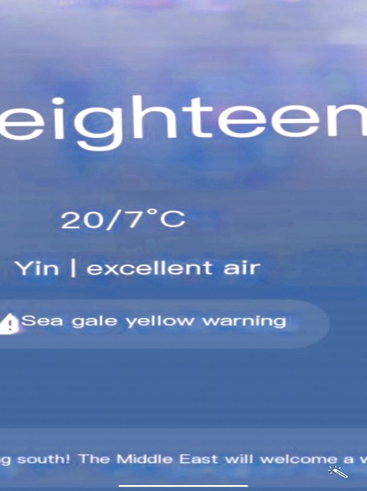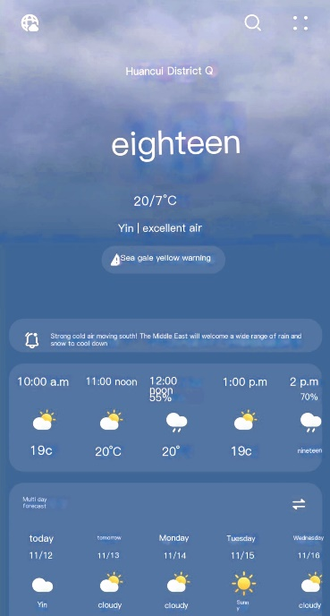using fingers to largen the charact er
7. 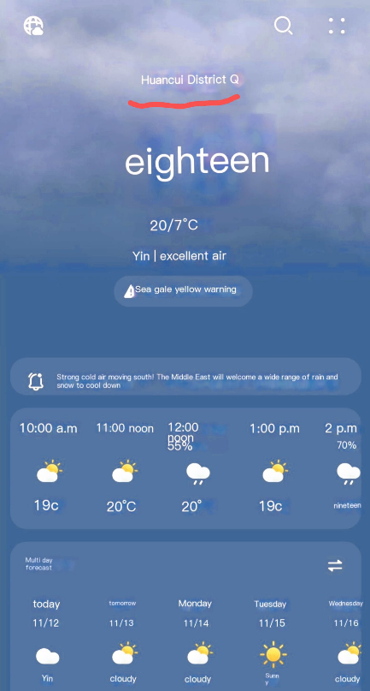click here to see the weather of

different region

3. Double click the screen to read the text out.